Power BJT – Introduction:
Bipolar Junction Transistor (BJT) is a three terminal, three layer, two junction semiconductor device.
Emitter(E), Base(B) and Collector(C) are the three terminals of the device.
Note:
(1) This page discuss about the Power BJT.
(2) Signal level Transistor configurations, operation, characteristics are not the scope of this page.

Power Transistor Symbol:
The symbol of the Power BJT is same as signal level transistor.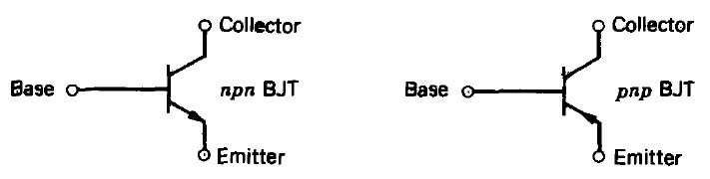

Power BJT Structure:

The construction of the Power Transistor is different from the signal transistor as shown in the following figure.
The n- layer is added in the power BJT which is known as drift region.
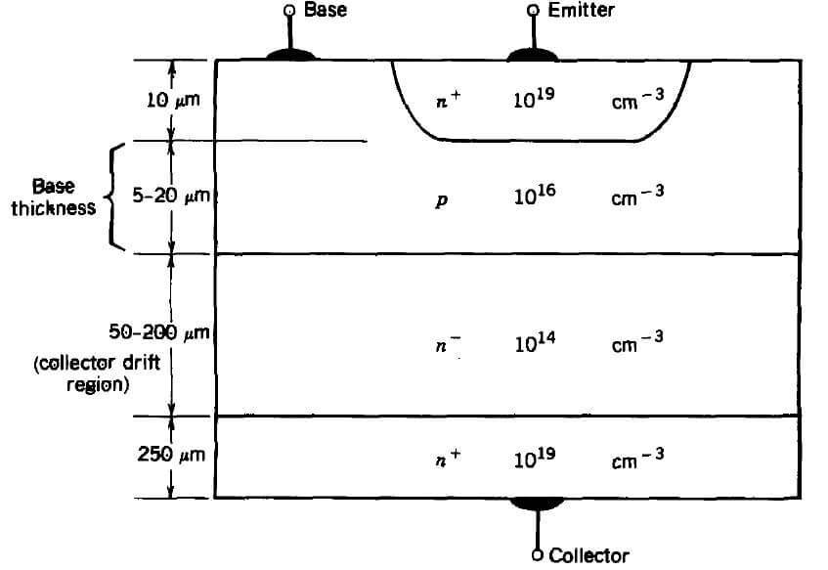
- A Power BJT has a four layer structure of alternating P and N type doping as shown in above NPN transistor.
- It has three terminals labeled as Collector, Base, Emitter.
- In most of Power Electronic applications, the Power Transistor works in Common Emitter configuration.
- ie, Base is the input terminal, the Collector is the output terminal and the Emitter is common between input and output.
- In power switches NPN transistors are most widely used than PNP transistors.
- The characteristics of the device is determined by the doping level in each of the layers and the thickness of the layers.
- The thickness of the dirft region determines the breakdown voltage of the Power transistor.

Power BJT – VI Characteristics:
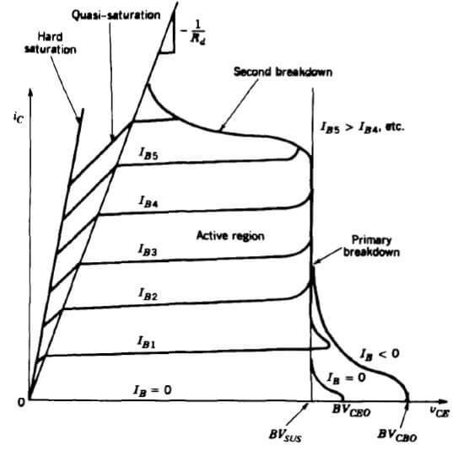
- The VI characteristics of the Power BJT is different from signal level transistor.
- The major differences are Quasi saturation region & secondary breakdown region.
- The Quasi saturation region is available only in Power transistor characteristic not in signal transistors.
It is because of the lightly doped collector drift region present in Power BJT.
- The primary breakdown is similar to the signal transistor’s avalanche breakdown.
- Operation of device at primary and secondary breakdown regions should be avoided as it will lead to the catastrophic failure of the device.

